Dead Sea Scroll (~168 BC): Septuagint (~250 BC)
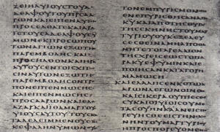
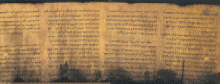

Papyrus fragment of John (~117 AD) Papyrus of Revelation (250 AD)
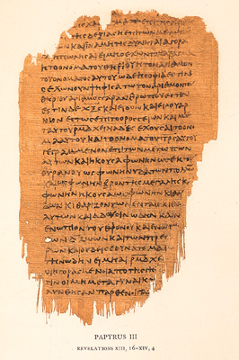
(earliest copy of New Testament scriptures)

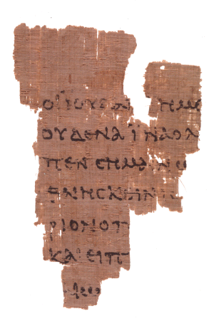

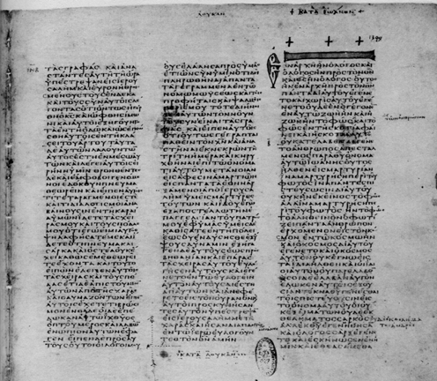
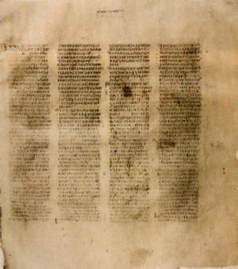
Codex Sinaticus (~340 AD) Codex Vaticanus (~350 AD)

