怎么知道圣经是正确的? 你怎么知道圣经是神的话?
How do you know the Bible is right? (How do you know the Bible is God's word?)
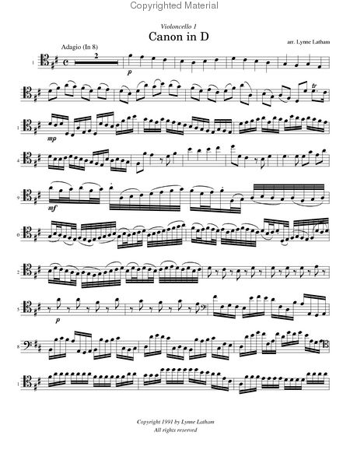
What a Christian accepts as truth:
- God is. (He exists).
- God speaks. (He communicates).
- We can understand.

How does God speak to us?
- Creation
- Conscience
- Bible:
- Jesus

The Bible is God’s Word?

1. God’s Word. The Bible claims it is God’s Word. Over 3600 times it says:‘耶和华这样说/This is what the Lord says：
全部圣经都是 神所默示的，在教训、责备、矫正和公义的训练各方面，都是有益的, 为要使属 神的人装备好，可以完成各样的善工。 提摩太后书 3.16-17
最要紧的，你们应当知道：圣经所有的预言，都不是先知自己的见解，因为预言不是出于人意的，而是人受圣灵的感动，说出从 神而来的话。 彼得后书 1.20-21

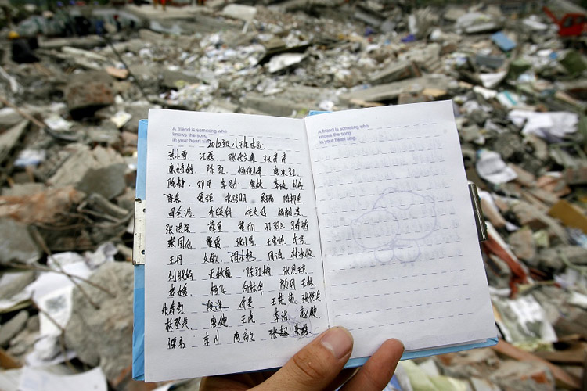
2. God’s Journal: It makes sense for God to give us his thoughts in written form. This is how we communicate most deeply with another.
耶和華說、我的意念、非同你們的意念、我的道路、非同你們的道路。天怎樣高過地、照樣我的道路、高過你們的道路、我的意念、高過你們的意念。 以賽亞書 55.8-9
我父已经把一切交给我；除了父没有人认识子，除了子和子所愿意启示的人，没有人认识父。 马太福音 11.27
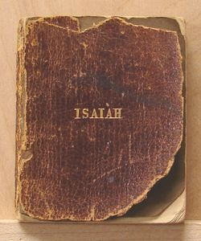
3. Common Theme. The Bible, a collection of 66 books, was written in three languages over a 1500 year time frame by more than 40 writers. It has a common theme: our separation from God, how we’re lost and wandering, and God’s way to bring us back.

4. Best seller: It’s the world’s best-selling book, with maybe 4 billion or more Bibles printed. It’s translated into nearly 2500 languages. There’s a good chance the Bible contains at least some truth.

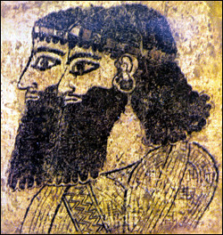
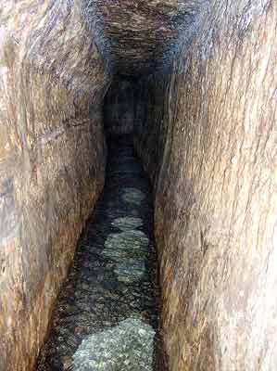
5. Historical accuracy. There’s no mistakes that must be fixed in reference to history and locations. Example: Luke mentions 32 countries, 54 cities and 9 islands in his two books. [Luke] should be placed along with the very greatest historians. (Sir William Ramsey) Example: Water tunnel in Jerusalem, found 200 years ago. Archeology has shown the accuracy of people/places/ events. Over 25,000 archeological finds reinforce the truth of the Bible. Example: Hittites, Assyrians.

*** 6. Prophecies. The Bible is full of prophecies (future predictions), over 1500 in the Old Testament. Question: If a text contains prophecies that don’t come true, what does that say about that book?” (it’s false). Fulfilled prophecy is a powerful evidence that the Bible is true. Over 300 prophecies relate to Jesus.
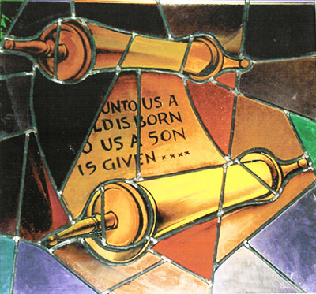
Eg: Jesus would be born in Bethlehem (not Beijing or Calgary) – predicted 700 years before by Micah: 伯利恒以法他啊！你在犹大诸城中虽然细小（“伯利恒......细小”有古卷作“以法他家啊，你在犹大诸族中虽然细小”），必有一位从你那里出来，为我作以色列的统治者；他的根源从太初，从亘古就有了。彌迦書 5.2
Eg: Jesus would come from Egypt – predicted over 700 years before, by Hosea: 约瑟就起来，连夜带着孩子和他母亲往埃及去，住在那里，直到希律死了，为的是要应验主借先知所说的：“我从埃及召我的儿子出来。” 马太福音 2.14-15
Eg: Jesus would die by crucifixion – predicted over 1000 years before by King David:
犬类围着我，恶党环绕我，他们扎了我的手我的脚。我能数算我全身的骨头，他们却瞪着眼看我。他们彼此分了我的外衣，又为我的内衣抽签。 诗篇 22.16-18

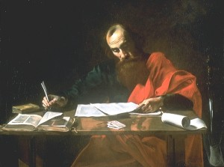
7. Changed lives. The Jewish persecutor Saul, when he encountered the risen Jesus, became a Christian and changed his name to Paul. God’s Word affected him so much, he was willing to die for Jesus – and did.
“基督耶稣降世，为要拯救罪人。”这话是可信的，是值得完全接纳的。在罪人中我是个罪魁。可是，我竟然蒙了怜悯，好让基督耶稣在我这个罪魁身上，显明他完全的忍耐，给后来信他得永生的人作榜样。 提摩太前书 1.15-16
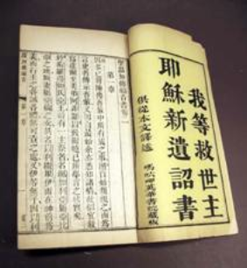
Other related questions:
- how did the Bible get written?
- how did the Bible get translated?

